Shahjalal University of Science and Technology

Department of Computer Science and Engineering



Title of the Project

Package and FnF Suggestion Generator

**Student:** *(Md Shah Ali, 2013337023, 4/2, Dept. of FET)*

**Supervisor:** *(Professor Dr. Mohammad Reza Selim, Professor, Dept. of CSE)*

4th September 2018

Shahjalal University of Science and Technology

Department of Computer Science and Engineering



Title of the Project

Package and FnF Suggestion Generator

A Project submitted to the Department of Computer Science and Engineering,  
Shahjalal University of Science and Technology, in partial fulfillment of the requirements  
for the degree of B.Sc (2nd Major) in Computer Science and Engineering.

**Student:** *(Md Shah Ali, 2013337023, 4/2, Dept. of FET)*

**Supervisor:** *(Professor Dr. Mohammad Reza Selim, Professor, Dept. of CSE*

4th September 2018

Recommendation Letter from Supervisor

This student, Md Shah Ali, whose project entitled “Package and FnF Suggestion Generator”, is under my supervision and agree to submit for examination.

Professor Dr. Reza Selim

Professor  
Dept. of CSE

# Qualification Form of B.Sc. (2nd Major) Degree

We hereby certify that this project titled “Package and FnF Suggestion Generator”, submitted by Md Shah Ali, conforms to acceptable standards and is fully adequate in scope and quality to fulfill the requirements for the degree of B.Sc. (2nd Major) in Computer Science and Engineering.

|  |  |  |
| --- | --- | --- |
| ________________  Head of the Dept.  Professor Dr. Reza Selim  Professor | _______________________  Chairman, Exam. Committee  Professor Dr. Reza Selim  Professor | __________________  Supervisor  Professor Dr. Reza Selim  Professor |

# Acknowledgement

Gratitude to the almighty for blessing me with the chance to take CSE 2nd Major Degree and complete it without any trouble.

First, I would like to thank my supervisor Professor Dr. Reza Selim from the core of my heart for giving me the idea and guiding me to make this project come into live with his valuable time. I am really grateful to him. Thanks to my friends Ali Akbar Tanim, Md Saddam Hossain Shahed, Anam Ibna Harun, for helping me with their android devices as well as with their ideas for designing the interface of the application.

Finally, I would like to thank the authority and the teachers who have been working hard for creating such a chance to take CSE as 2nd Major for the students like us who have passion and love for CSE and dream for learning something beyond their respective subject.

# Abstract

The application “Package and FnF Suggestion Generator” was developed with an intention to help the people of Bangladesh choosing best package, corresponding FnF and Super FnF and best operator for them based on their call log. One can easily activate his/her suggested best package and add suggested FnF and Super FnF with this app.

The application will detect the current package automatically by sending SMS or through USSD call, insert outgoing call log into database, read outgoing call log and compare current package cost with the other package cost for current call log and give you suggestion. For new outgoing call after installation, it will automatically insert this call details into database.

# Table of Contents

1. Introduction 1

1.1 Problem Definition 2

1.2 Purpose 2

1.3 Scope 2

1. Background 3

2.1 Background Study 3

2.2 Existing Works 3

2.3 Probabilities 3

1. Requirement Analysis and Specification 4

3.1 Major Requirements 4

3.2 Minor Requirements 4

3.3 Requirement Gathering 4

3.4 Interviewing the Users 5

3.5 Selecting the Best Alternative Design Strategies 7

3.6 Finalizing the Design of the Prototype 7

3.7 Use-Case Modeling 8

3.8 Constraints 9

3.9 Assumptions and Dependencies 9

1. System Design 10

4.1 Data Flow Diagram 10

4.2 Activity Diagram 11

4.3 Class Diagram 12

4.4 ER Diagram 13

4.5 Input Interface 13

4.6 Output Interfaces 14

1. System Assessment 15

5.1 Implementation 15

5.2 System Requirement 15

5.3 Testing 16

5.4 Testing Strategies 16

5.5 Result Analysis 18

1. Conclusion and Future Work 19

Introduction

In Bangladesh, there are four phone-operators. Each of them has several packages based on different conditions. People often find it hard to choose which package is best and economical for him. Besides, these operators provide special call rate for one special number, called Super FnF and some other number called General FnF. Now, here comes the point. It is almost impossible to predict Super FnF and General FnF number which will be economical for them. Above all, most of the people don’t know how to migrate form one package to another and add Super FnF or General FnF number. Hence, they can’t use the feature of his current package which further cause waste of both time and money. It is also a hard task to find the best economical operator for a general person as he is not likely to research on other operator’s call rate. Indeed, it is not an easy task for person to compare about 40 packages call rate. Some may consider it as waste of time. This app will help the people of Bangladesh in these aspects.

This application was developed only for the people of Bangladesh to help them choosing best package, fnf numbers, operator. With this app, users will be able to activate suggested package and add fnf or super fnf by clicking on the corresponding button. The app will automatically send sms for activating suggested package or adding fnf or super fnf. The app will show the both costs for all packages of the current operator and all operators so that user can manually compare. Besides, the amount, an user could save by using the suggested package or operator, is also shown.

The app will automatically detect user’s current operator. Based on the current operator it will send sms to corresponding operator number or make USSD call for checking current package of the current operator. It will receive and read the returned sms for current package. All the available call logs will be stored in database. After installing the app, if a user makes new outgoing call, his call log will automatically be stored in database though he uses any kind of app that deletes call log. It won’t store any outgoing call log that has duration 0 second meaning that the call was missed. By reading the user’s call log form database based on each number, it will calculate the probable cost for each of packages of their current operator, compare other package cost with current package, suggest the package with least cost and show how much an user could save if he used the suggested package. On that package if there is any option of super fnf, the number with longest call duration will be selected. Other fnf numbers will be selected in the same based on total call duration. It will also suggest users for operator that will be more economical than user’s current operator.

* + 1. Problem Definition

Generate suggestion for package, corresponding fnf and super fnf and best operator for a user that will help to reduce user’s calling expense.

* + 1. Purpose

This document aims to give a brief description about the project Package and FnF Suggestion Generator. With the help of this document the needs of the users (people of Bangladesh) and the solution of their needs will be clearly depicted. In other words, this document will provide a basis for validation and verification.

* + 1. Scope

1. Provide suggestion for best package, corresponding fnf and super fnf, best operator
2. Provide facility to activate package with a single button click
3. Provide facility to add fnf or super fnf with button click
4. Show cost of other packages of the current operator
5. Show cost of other operators

Background

* + 1. Background Study

There are five operators in Bangladesh (Airtel, Robi, Grameenphone, Banglalink, Teletalk) where each of them have several packages. Different packages have different advantages. For example, operators have different call rates for peak hour (12:00 am – 8:00 am), non-peak hour, same operator, different operator. People may be confused or wrong in the selection of their proper operator or package. Besides, choosing fnf numbers. Hence, their day to day calling expense may rise. Here the app will help people to select best operator, package, fnf for them by analyzing his/her call log and thus decrease the calling expense.

Most of the people of Bangladesh, using mobile phone, use android devices as it has been comparatively cheaper. Resource’s accessibility is pretty easy in android OS (operating system) rather than IPhone or Windows and there is a good community support. Hence, for developing this app, Android Operating System was used.

* + 1. Existing Works

An operator Robi has a web service that provides suggestion for best package based on questioning. As it is a web service it can’t read call log and the user has to answer questions which may go wrong. There doesn’t exist any other app like this app.

* + 1. Probabilities

Researching further, one can modify the app which will crawl data (call rate) from different operator’s website automatically.



Requirement Analysis and Specification

* + 1. Major Requirements

1. Suggesting best package for user’s current operator
2. Suggesting Super FnF and General FnF number for the corresponding package
3. Suggesting best operator and it’s best package
   * 1. Minor Requirements
4. Addition of “Activate” button to activate suggested package
5. Addition of “Add” button to add suggested fnf or super fnf number
6. Showing the cost details of other package so that user can compare themselves
7. Showing the cost details of other operator
   * 1. Requirement Gathering

Major requirements were gathered from my supervisor. Some people opposed for the suggestion of best operator as users are not likely to change their phone number. Minor requirements were gathered from some of the users by asking them several questions like what additional feature they wanted. Some of them asked to add the cost details of other package and some asked for cost of other operator. Some of them asked for adding suggestion for best internet package.

* + 1. Interviewing the Users

1. What are the main functionality of the app?

Answers:

1. Suggest best package
2. Suggest best package’s super fnf
3. Suggest best package’s general fnf
4. Show best operator name
5. What are the features?

Answers:

1. Add a button to activate suggested package
2. Add button to add fnf or super fnf
3. Show other package cost
4. Show other operator cost
5. What are the additional features?

Answers:

1. Show suggestion for internet package
2. Show suggestion for best recharge offer
3. Check balance
4. Is it single page application or multipage application?

Answers:

1. Multipage
2. What style should be used in activate button?

Answers:

1. Button should be rectangular shape with round corner and color should be light green. It should be placed underneath the package name. The button name should be “+Activate”.
2. What style should be used in “add fnf” button?

Answers:

1. Same as the activate button
2. Where the package name will be displayed?

Answers:

1. In the first page and it should be circular shape with light green background
   * 1. Selecting the Best Alternative Design Strategies
2. Multipage can be achieved by using multiple activity and multiple tab. Here, tab layout will be easier for user as user can easily move to these pages of different content with both slide and tap on button.
3. As there is no easy option to track whether internet is used by mobile operator or Wifi and lack of available resources, suggestion for internet package feature is omitted.
4. Recharge offer may change very frequently and there no API for any of the operator to track offer. So this feature is also omitted.
5. Checking balance is not that necessary. So it is also omitted
6. For the ease of coding and support of both landscape and portrait mode, fragment was used for each of the three pages.
   * 1. Finalizing the Design of the Prototype

First page (Best Package):

It will contain 5 cards of card layout. The first card will contain best package name and activate button with headline on top named Suggested Package. The second card will contain suggested package details like how many fnf or super fnf is available in the suggested package. The third card will contain current package details. Fourth card will contain other package cost in a list. Fifth card will show the amount that user could save if he used the suggested package. Each of the card will have its own heading.

Second Page (FnF):

Card layout will be used in linear layout. First card will contain Super FnF number and add button if super fnf is available for the suggested package. Second card will contain all the general fnf numbers available and add button to add fnf.

Third Page (Best Operator):

Card layout will be used along with linear layout. First card will show the best operator name in a circle and best operator’s best package in rounded rectangle. Second card will show other operators cost in a list. Third card will show the amount of savings a user could make if he used the suggested operator and its package. Fourth card will show the best operator’s possible super fnf the fifth card will show its general fnf list.

* + 1. Use-Case Modeling

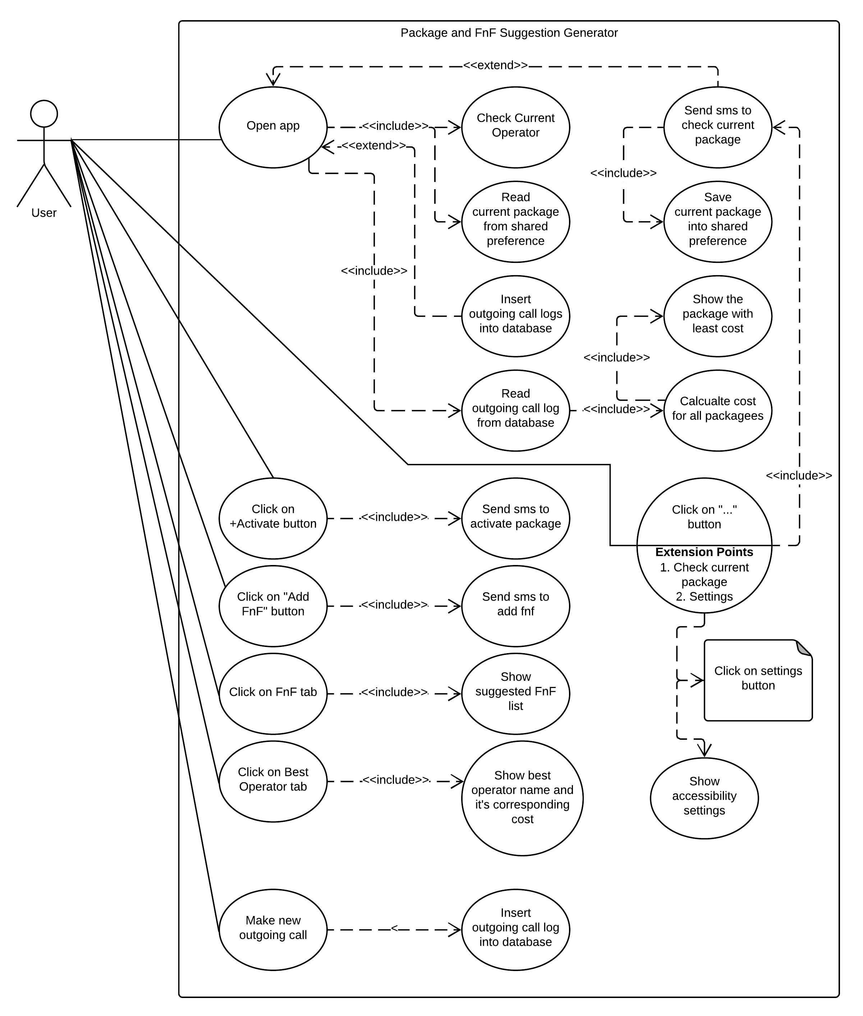

Figure 1: Use Case Diagram

* + 1. Constraints

The Banglalink operator doesn’t have any system to check package through sms. The airtel operator costs 0.55 taka to check package though sms but 0 taka through USSD call. The Teletalk operator doesn’t have any working service to check current packge. The Grameenphone operator sometimes take a long time to reply sms with current package.

Some of the devices like Mi doesn’t allow the app to read sms automatically. It is required to allow this option manually by the user.

* + 1. Assumptions and Dependencies

It was assumed that Sim Card remains same for all outgoing calls. Different recharge offers were not taken into count.

The whole application is dependent on the call rate found in the operator’s website.



System Design

* + 1. Data Flow Diagram

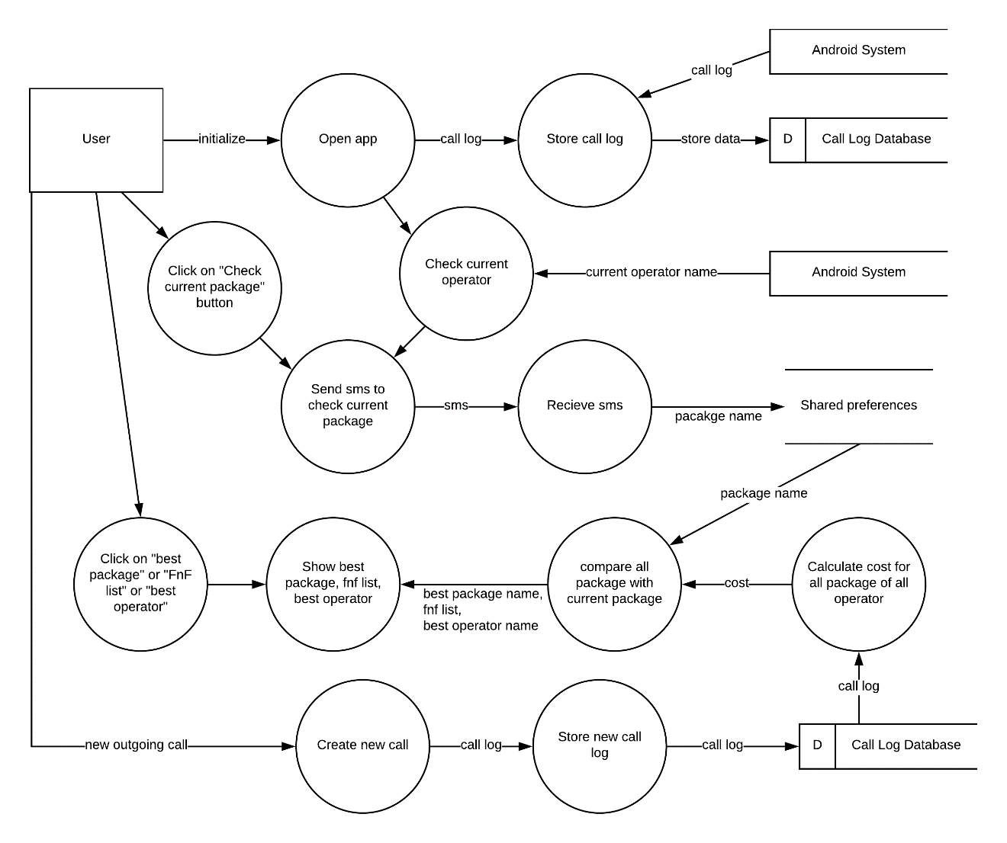

Figure 2: Data Flow Diagram

* + 1. Activity Diagram

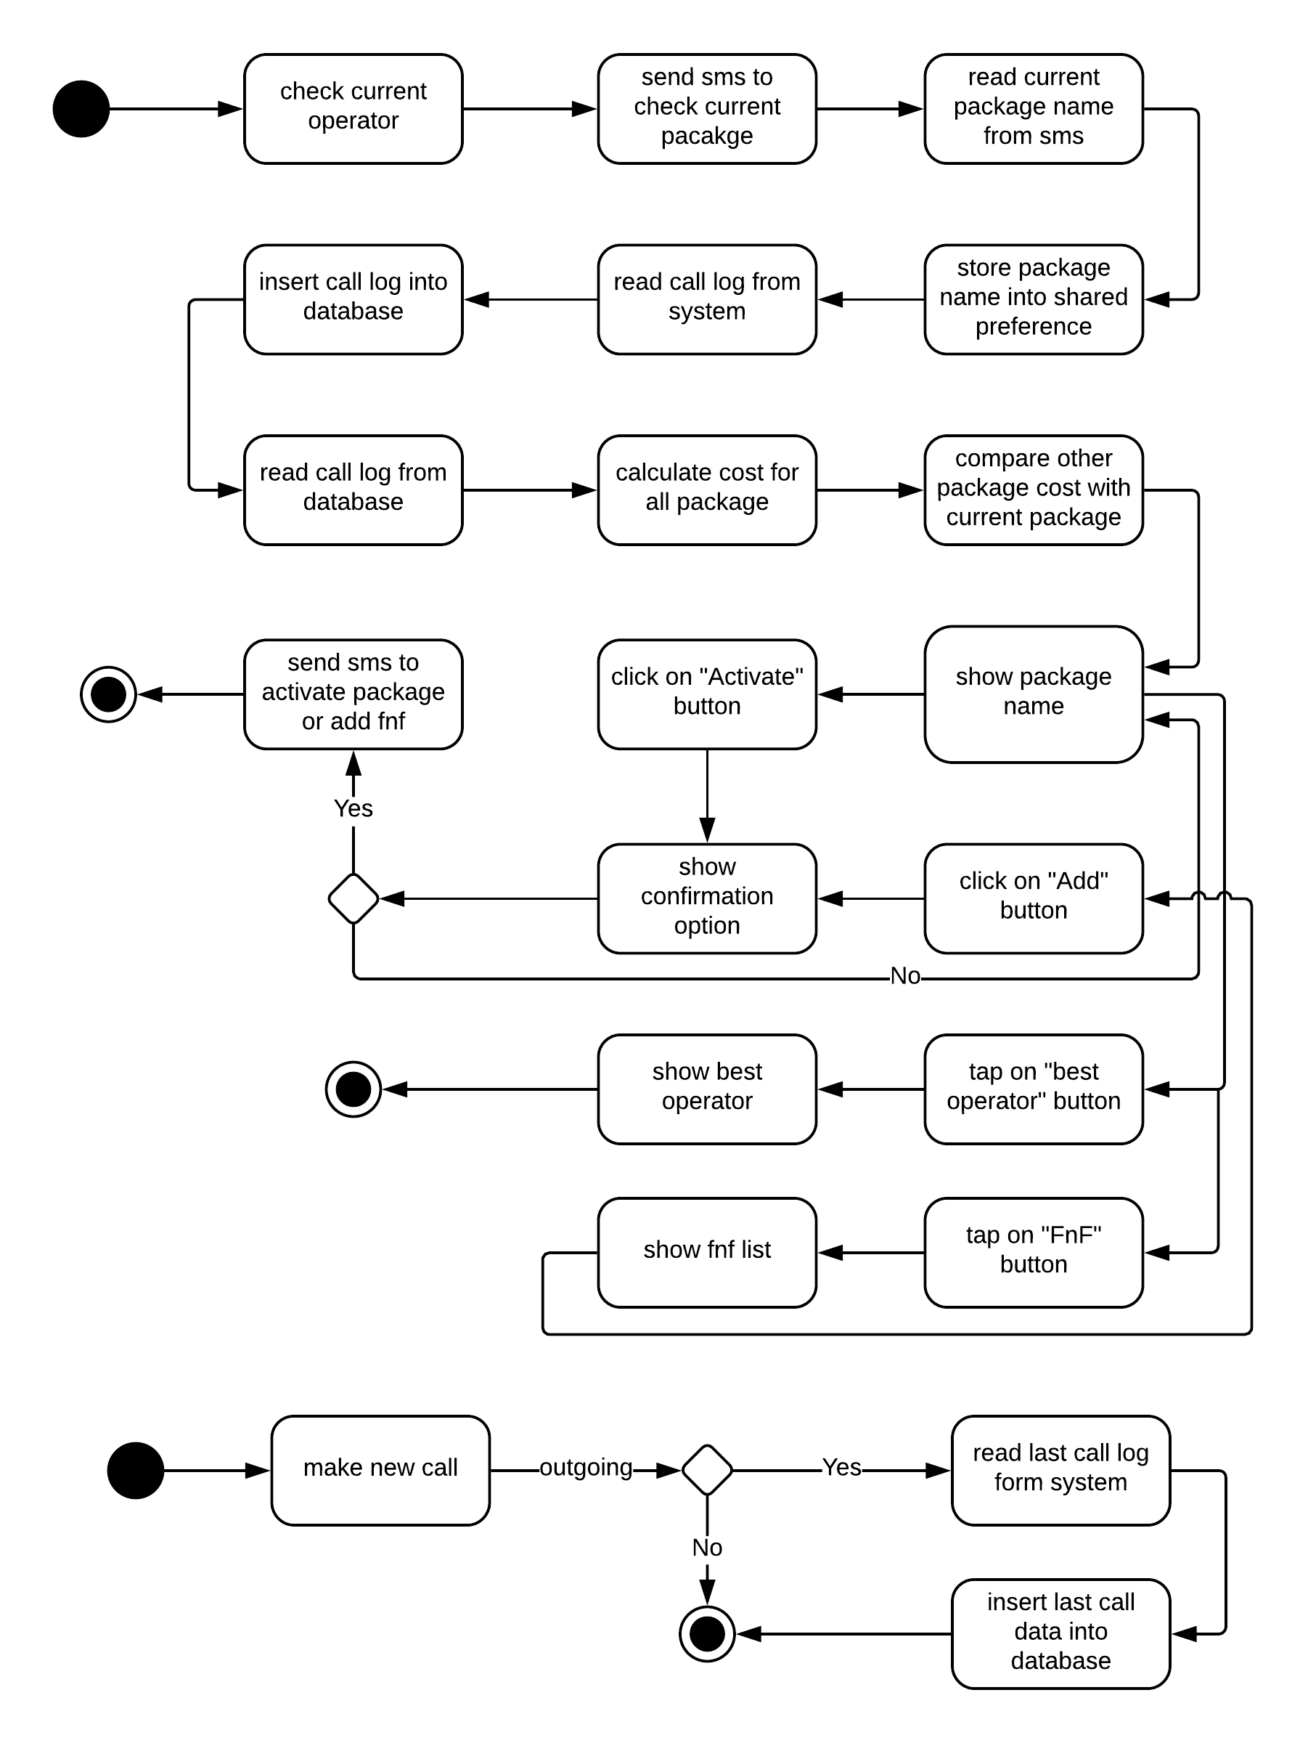

Figure 3: Activity Diagram

* + 1. Class Diagram

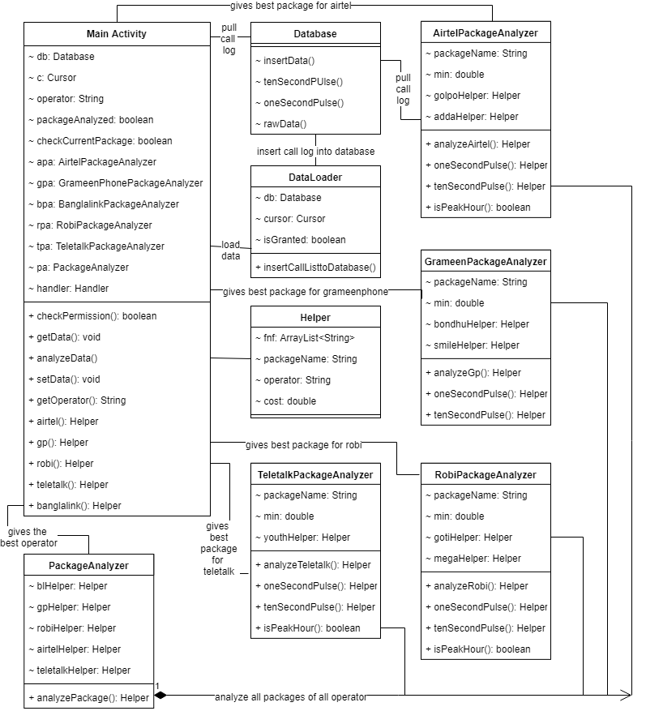

Figure 4: Class Diagram

* + 1. ER Diagram

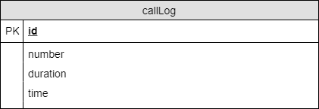

Figure 5: ER Diagram

* + 1. Input Interface

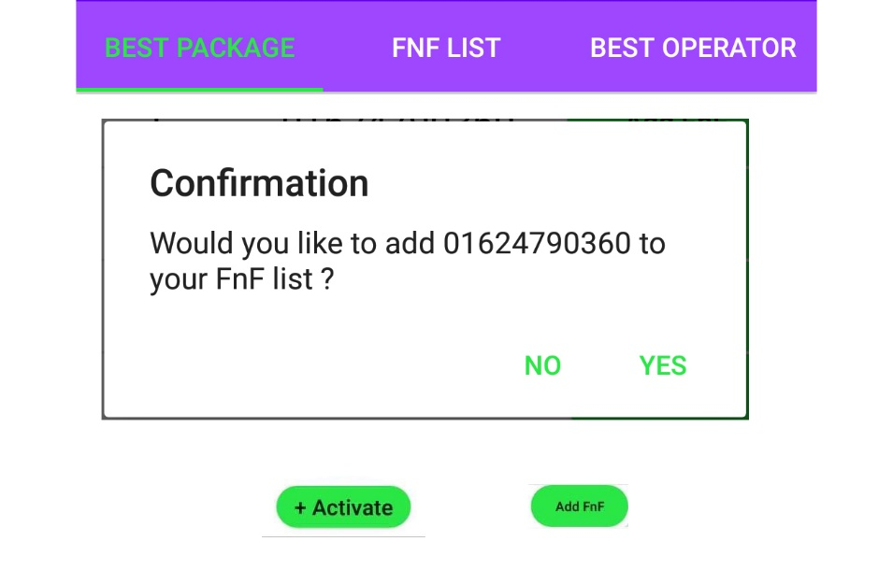

Figure 6: Input Interfaces

* + 1. Output Interfaces

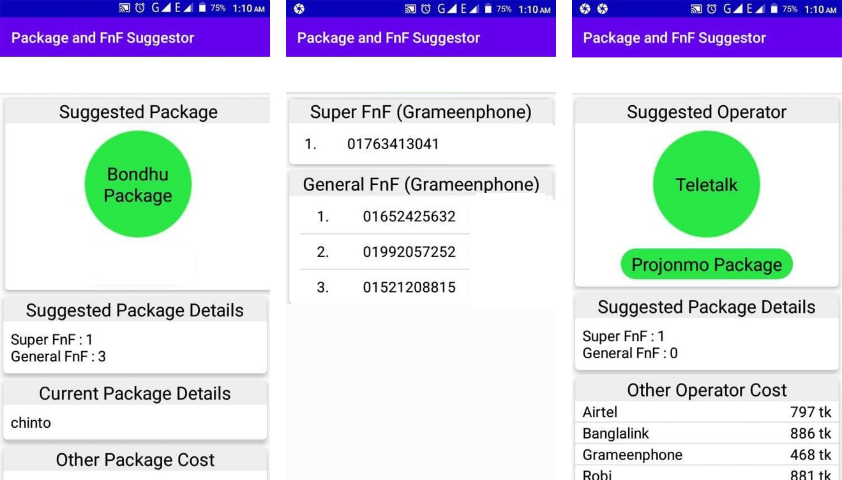

Figure 7: Output Interfaces



System Assessment

* + 1. Implementation

**Tools:**

As android OS is built on Java, the app was developed with the language Java. Here, Android Studio was used as it provides wide variety of integration of several features like Firebase, Play Services etc. Besides, it supports external emulator like Memu which is faster than its internal emulator. This tool supports with its autocomplete feature greatly.

For testing with dummy values, a virtual android system named Memu was used along with several real devices.

**Android Services:**

To detect new outgoing call, receive sms, read sms a service was used that extends Broadcast Listener was used. When new call or sms is created, the service is fired and perform certain tasks like insert call into database or read sms and save it into Shared Preference.

Banglalink doesn’t have any option to check current package by sms. So, the app makes USSD call and to read the USSD response android needs to have accessibility permission. Hence, an Accessibility Service was created to track the USSD response.

**Source code**: <https://github.com/shahalihridoy/PackageandFnFSuggestionGenerator.git>

* + 1. System Requirement

Operating system: Android

Minimum API level: 18

Minimum android version: 4.2.1

* + 1. Testing

The app was tested on several android devices like Huawei, Samsung, MI, Symphony of different android versions like Lollipop, Marshmallow, Nougat, Oreo and showed the best possible results. The users were satisfied with the outcome, the app provided. For example, it gave the accurate result for Super FnF as well as other.

* + 1. Testing Strategies

Given Data Set:

Number duration (min: sec) time

01763413041 10:12 02:43pm

01992057252 5:10 10:23am

01521208815 3:24 8:30am

0182444030 5:10 11:20pm

01763413041 1:12 02:43pm

01652425632 7:52 3:30pm

01763413041 17:12 02:43pm

01992057252 3:10 10:23am

01521208815 2:24 8:30am

0182444030 9:10 11:20pm

01763413041 3:12 02:43pm

01652425632 5:52 3:30pm

01652425632 1:52 3:30pm

Operator: Grameenphone

Super FnF

We can see from the data set that it contains a number 01763413041 which has a total duration of 27:24 (min:sec) which is far longer than the call duration of other number. So, our expected result is this number and it was found in the app suggestion.

General FnF Testing

As Robi is combined with Airtel and maximum number of data set is Airtel and Robi, the best package should be Mega FnF which possess 1 super fnf and 81 fnf. It was found as like as our prediction.

Operator Testing

Here most of the number based on call total call duration is Robi and Airtel. So, it was expected that the app will suggest for Robi operator and it did not do so. Because, Teletalk provides a better package which has one super fnf with more less cost than Grameenphone and other operator.

Testing examples are given below

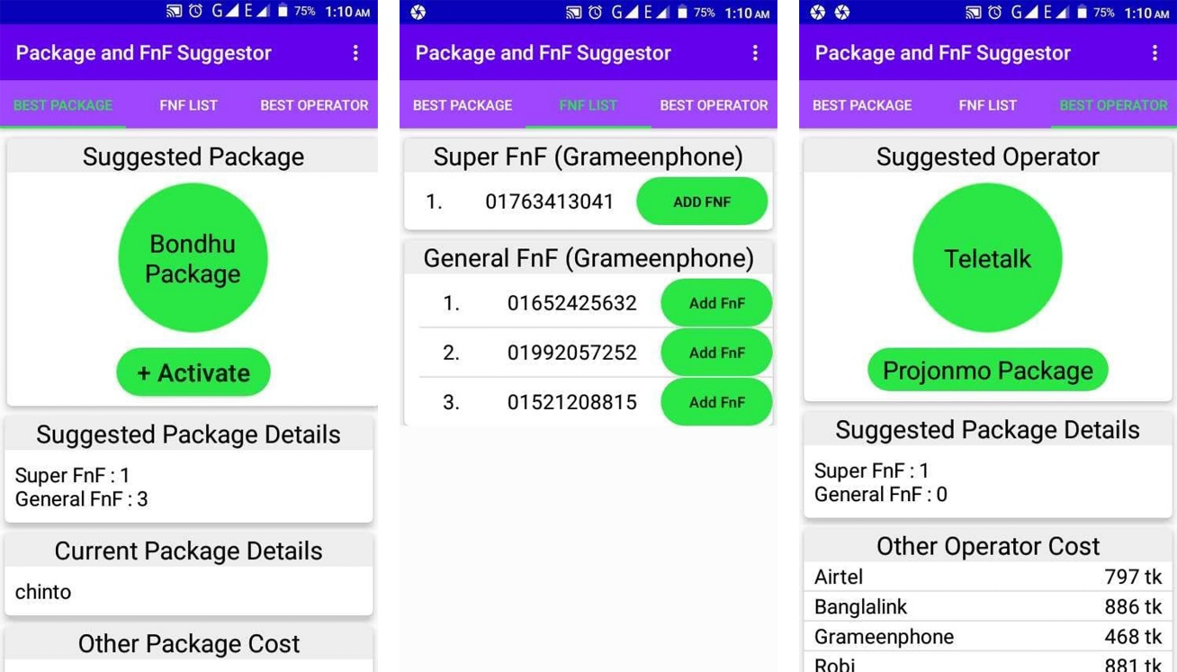

Figure 8: Proof of Functionality

* + 1. Result Analysis

For both real device and dummy device call log, result was perfect as the user desired.



Conclusion and Future Work

The app was developed to help people choosing economy Package for phone call as well as their corresponding Super FnF, General FnF. User can easily activate his/her suggested best package, fnf and super fnf by clicking on specific buttons without any doubt. While building the app, it was assumed that all the phone calls were made by same SIM card. The app can only detect operator of SIM-1 in dual sim phone. Hence, it will give suggestion only for SIM-1 in dual sim phone.

Calling cost was calculated by hard coded call rate. This app can be further developed to crawl data (call rate) from the operator’s website automatically. Functionality to give suggestion for both SIM in dual sim phone can be introduced.